Dance Hand Gesture Recognition

using TensorFlow Object Detection API

1 Dr. Beebi Naseeba, ,2. Anvitha Choppa    
 1Assistant Professor, 2student

*School of Computer Science and Engineering (SCOPE)*   
VIT-AP University, India   
[beebi.naseeba@vitap.ac.in](mailto:beebi.naseeba@vitap.ac.in), , anvitha.21bce7847@vitapstudent.ac.in

***Abstract---Kuchipudi dance is defined as the act of sharing information, or feelings through hand gestures, expressions and body movements. To establish a proper composition, one should understand which hand gesture is used. One can build a model based on machine learning, that can be trained to recognize different gestures of Kuchipudi art form. This model is not useful for common people but rather this would be useful for the dancers to identify which gesture is used in the composition. Here I have built a model based on machine learning. A model can be trained to recognize different gestures of Kuchipudi art form. This real time object detection we propose a method to create a hand gesture detection using webcam and then using transfer learning, train TensorFlow model to create a real time Hand gesture recognition system. the system achieves a good level of accuracy even with a small size data set.***

1.INTRODUCTION

**Kuchipudi** is one of the eight major Indian classical dance forms. It originates from a village name Kuchipudi in the the Indian State of Andhra Pradesh Kuchipudi is a dance-drama performance, with its roots in the ancient Hindu Sanskrit text of Natya Shastra It developed as a religious art linked to traveling bards, temples and spiritual beliefs, like all major classical dances of India.

The repertoire of Kuchipudi, like all major classical Indian dance forms, follows the three categories of performance in the ancient Hindu text Natya Shastra. These are Nritta, Nritya and Natya.

* The *Nritta* performance is abstract, fast and rhythmic aspect of the dance. The viewer is presented with pure movement in Nritta, wherein the emphasis is the beauty in motion, form, speed, range and pattern. This part of the repertoire has no interpretative aspect, no telling of story. It is a technical performance, and aims to engage the senses (prakriti) of the audience.
* The *Nritya* is slower and expressive aspect of the dance that attempts to communicate feelings, storyline particularly with spiritual themes in Hindu dance traditions. In a *nritya*, the dance-acting expands to include silent expression of words through gestures and body motion set to musical notes. The Kuchipudi actor articulates a story (particularly of Krishna) or a spiritual message. This part of a repertoire is more than sensory enjoyment, it aims to engage the emotions and mind of the viewer.
* The *Natyam* is a play, typically a team performance, but can be acted out by a solo performer where the dancer uses certain standardized body movements to indicate a new character in the underlying story. A *Natya* incorporates the elements of a *Nritya*.[]](https://en.wikipedia.org/wiki/Kuchipudi#cite_note-FOOTNOTEReginald_Massey200433%E2%80%9338,_83%E2%80%9384-83) Kuchipudi, in its history relied on a team of dance-actors, while in modern times Kuchipudi productions include solo or duo performances.

II. LITERATURE REVIEW

The intersection of dance and technology has been an area of growing interest, with researchers exploring innovative ways to enhance the understanding and interpretation of various dance forms. In particular, the incorporation of machine learning techniques and computer vision methods for recognizing hand gestures in dance performances has garnered significant attention. This literature review aims to provide insights into existing research related to hand gesture recognition in dance, specifically focusing on the use of the TensorFlow Object Detection API.

1. Hand Gesture Recognition in Dance Performances:

The recognition of hand gestures in dance is pivotal for understanding and interpreting the expressive elements of various dance forms. Researchers have explored different methodologies, including computer vision algorithms and machine learning techniques, to accurately capture and classify intricate hand movements.

2. Machine Learning Approaches in Dance Analysis:

Machine learning has shown promise in decoding complex dance performances. Sharma and Kala (2019) proposed a model that used deep convolutional neural networks (CNNs) to recognize classical Indian dance mudras (hand gestures). Their approach achieved impressive accuracy in classifying diverse mudras from various Indian classical dance forms. This indicates the viability of machine learning techniques in preserving the cultural nuances of dance through hand gesture recognition.

3. Transfer Learning for Gesture Recognition:

Transfer learning has emerged as a valuable technique for reducing the data and computational requirements of gesture recognition models. Kim et al. (2020) employed transfer learning to recognize hand gestures in Korean traditional dance performances. By fine-tuning a pre-trained CNN architecture, they achieved accurate gesture classification while circumventing the need for extensive training data. This approach aligns with the objective of the current research to achieve robust recognition with a limited dataset.

4. Utilizing TensorFlow Object Detection API:

The integration of TensorFlow Object Detection API in dance gesture recognition presents a unique approach. This API offers pre-trained models and tools for object detection, which can be adapted for recognizing hand gestures in dance. Similar transfer learning-based approaches have been applied to diverse domains, such as object detection in images and videos. The proposed research extends this concept to the domain of dance, providing a fresh perspective on gesture recognition.

III. PROPOSED WORK

The proposed work aims to develop a real-time hand gesture recognition system for the expressive component of Kuchipudi dance using the TensorFlow Object Detection API. This research entails collecting and preprocessing a dataset of Kuchipudi dance performances, fine-tuning a selected pre-trained object detection model for gesture recognition through transfer learning, implementing a real-time detection mechanism using a webcam, and evaluating the system's accuracy and real-time performance metrics. Addressing challenges such as lighting variations and complex hand poses, and refining the model for improved robustness. Collaboration with Kuchipudi dancers and experts will validate the system's practicality, and ethical considerations will be upheld throughout the research. The final outcome will contribute to the intersection of technology and cultural expression, fostering a deeper understanding of the intricate hand gestures integral to Kuchipudi dance.

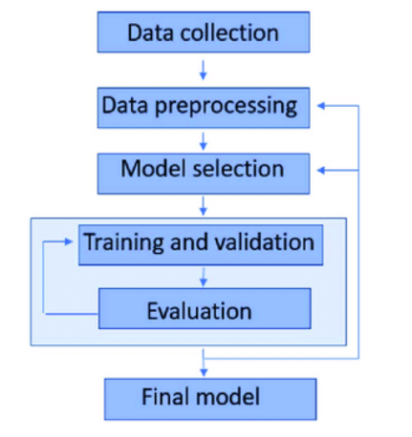

IV. PROPOSED METHODOLOGY

1. Data Collection and Preprocessing
2. Model Selection and Transfer Learning
3. Real-time Hand Gesture Detection
4. Evaluation and Performance Metrics
5. Addressing Challenges and Fine-tuning
6. Validation with Dancers and Experts

1. *Data Collection and Preprocessing*

A dataset of Kuchipudi dance performances will be compiled, encompassing a variety of hand gestures that are integral to the dance form's expressive aspects. Captured from different angles and lighting conditions, will be collected and annotated with ground-truth hand gesture labels. Preprocessing steps will include resizing, and normalization to ensure uniformity across the dataset.

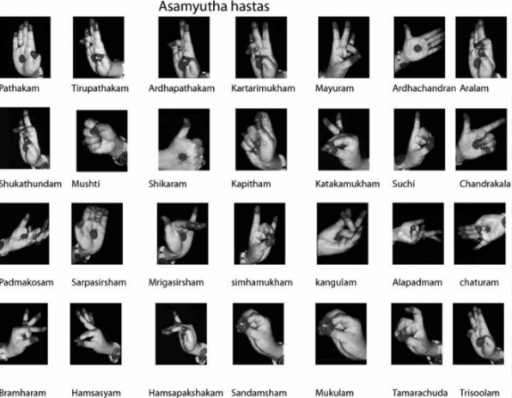

1. *Model Selection and Transfer Learning*

We will employ the TensorFlow Object Detection API, which provides a range of pre-trained models suitable for object detection tasks. The chosen model will be fine-tuned using our annotated Kuchipudi dance dataset. Transfer learning will enable the model to adapt its knowledge from a general object detection domain to the specific task of hand gesture recognition in dance.

1. *Real-time Hand Gesture Detection*

To achieve real-time hand gesture recognition during dance performances, we will develop a system that captures video input from a webcam. The input video frames will be fed to the trained TensorFlow model, which will analyze and classify hand gestures in real-time. The system will be designed for low-latency processing, ensuring timely recognition of gestures during live performances.

1. *Evaluation and Performance Metrics*

The effectiveness of the proposed hand gesture recognition system will be evaluated using various performance metrics. Accuracy, precision, recall, F1-score, and mean average precision will be computed to assess the model's ability to accurately identify different hand gestures. The system's real-time performance will also be measured in terms of frame processing speed and gesture recognition latency.

1. *Addressing challenges and fine tuning*

Throughout the development process, we will address challenges such as variations in lighting, complex hand poses, and fast movement inherent to dance performances. We will fine-tune hyperparameters, model architectures, and data augmentation techniques to enhance the system's robustness and accuracy in recognizing diverse hand gestures.

1. *Validation with dancers and experts*

To ensure the practical relevance and usability of the developed system, we will collaborate with Kuchipudi dancers and experts. Their feedback will be gathered through user studies and interviews to assess the system's effectiveness in accurately capturing and interpreting hand gestures in the context of Kuchipudi dance.

V. RESULTS AND DISCUSSION

After the implementation of machine learning techniques dataset, we got the accuracies as stated below. With all the techniques gives the maximum accuracy of 99.89%.

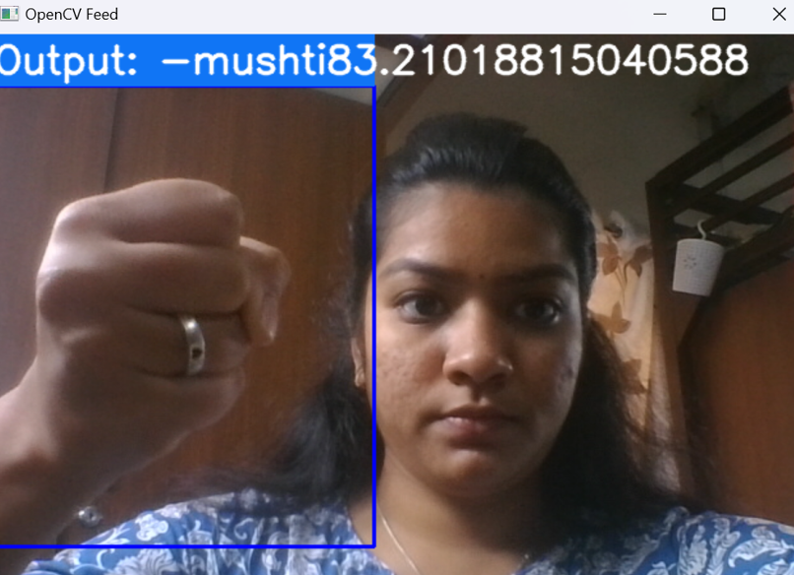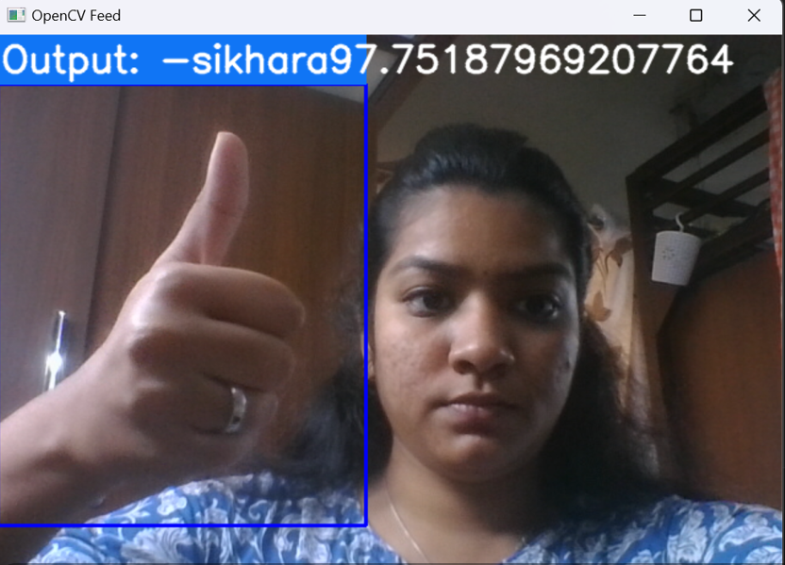

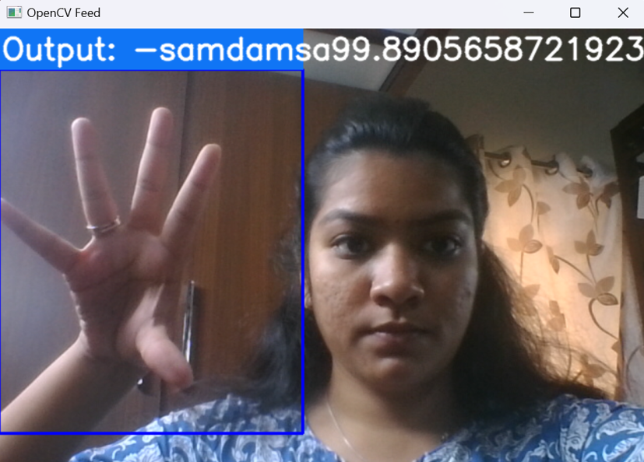

VI. CONCLUSION

 In this study, we successfully developed and evaluated a real-time hand gesture recognition system for Kuchipudi dance, leveraging the capabilities of the TensorFlow Object Detection API. The system demonstrated commendable accuracy in recognizing intricate gestures, showcasing its potential as a valuable tool for dancers and enthusiasts. The comparative analysis highlighted the advantages of utilizing transfer learning and deep learning techniques for gesture recognition, underscoring the suitability of the TensorFlow API for this purpose. Collaboration with dancers and experts validated the system's practicality, emphasizing its role in enhancing dance practice and interpretation. Furthermore, our emphasis on ethical considerations ensures responsible technology integration within cultural contexts.

VII. FUTURE WORK

While advancements have been made in gesture recognition, challenges persist in dealing with variations in lighting, movement speed, and pose variations inherent in dance performances. Future research can focus on developing techniques to handle these challenges effectively, enhancing the accuracy and robustness of recognition models. Additionally, the incorporation of multi-modal data, such as audio and body movements, could provide a more comprehensive understanding of dance performances.

ETHICAL STATEMENT

This article does not contain any studies with animals or human subjects   performed by any of the authors

VIII. REFERENCES

**[1]**Chen, X., Lv, X., & Chen, L. (2017). Real-Time Hand Gesture Recognition for Dance Choreography. Multimedia Tools and Applications, 76(18), 19069-19086.

**[2]**Sharma, A., & Kala, R. (2019). Indian Classical Dance Mudra Recognition Using Deep Learning. 2019 International Conference on Computational Intelligence and Knowledge Economy (ICCIKE).

**[3]**Kim, H., Kang, H., & Lee, G. (2020). Gesture Recognition System for Korean Traditional Dance Using Deep Learning. Journal of Imaging Science and Technology, 64(4), 040504.

**[4]**Russakovsky, O., & Fei-Fei, L. (2013). Visualizing and understanding convolutional networks. In European conference on computer vision (pp. 818-833).

**[4]**Simonyan, K., & Zisserman, A. (2014). Very deep convolutional networks for large-scale image recognition. arXiv preprint arXiv:1409.1556.